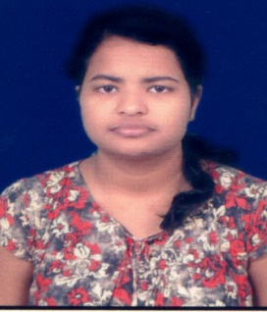**RESUME**

**SUBHASHREE PRIYADARSINI**

**D/o- Susanta Kumar Barik**

At- Mahatab Nagar, Kudiary

Po- Kudiary, Ps- Jatni

Dist –Khordha

PIN-752050

Mob No: 6370117505

E-Mail: subhashree2016p@gmail.com

**OBJECTIVE:**

Seeking a challenging and simulating job, where I can positively contribute my skills utilize my creativity for the benefit of the organization and acquire new skills to achieve the goal.

**PERSONAL SKILLS:**

Comprehensive problem solving abilities, Creativity, Responsibility, Team facilitator, Adaptability, Self-motivation, Interest for learning, honest, Hardworking, Enthusiastic, Optimistic, Compassionate

**EDUCATION QUALIFICATION:**

* 10th passed from Kudiary High School under BSE, Odisha in the year 2013 with 78.84%.
* 12th Arts passed from Govt. Women’s Jr. College, Puri under CHSE, Odisha in the year 2015 with 80.66%.
* BA (Psychology Hons.) passed from SCS (Auto) College, Puri in the year 2018 with 83.91%.
* MA (Psychology) passed from Utkal University, Vani Bihar in the year 2020 with 8.58 CGPA.
* Now doing Diploma Course in Guidance and Counselling from RIE, BBSR under NTSE

**COMPUTER KNOWLEDGE:**

* PGDCA
* Typing speed 40 wpm

**Experience:**

* Worked as an intern for 3 months in the Department of Psychiatry, IMS AND SUM Hospital, BBSR
* Practical exposure to Open Learning System, BBSR and Mission Ashara, BBSR

**HOBBIES:**

* Reading Books , Painting, Craft making, Listening to music, Gardening

**PERSONAL DETAILS:**

Name : Subhashree Priyadarsini

Father’s Name : Susanta Kumar Barik

DOB : 15.07.1998

Gender : Female

Marital Status : Unmarried

Nationality : Indian

Religion : Hindu

Category : OBC

Language’s known: English, Hindi & Odia.

Permanent Address: -do-

**DECLARATION**

I do hereby declare that all the above information are true and correct to the best of my knowledge.

**Place: Khordha, Odisha** 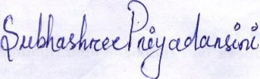

**Date: 12/06/2021 Signature**